## horizontal line

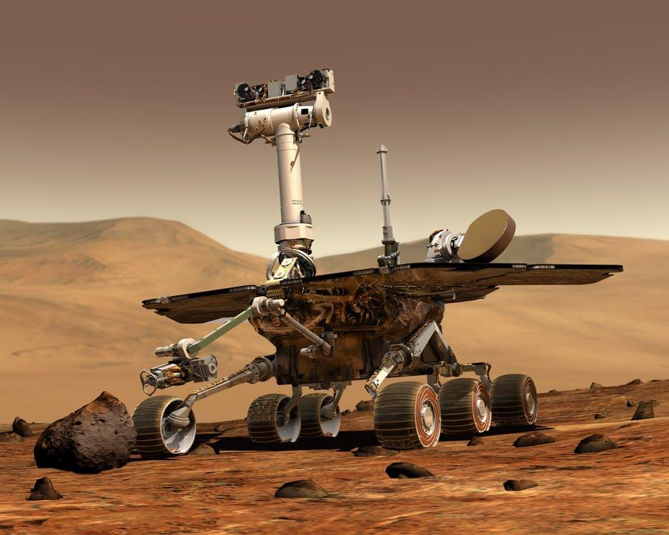

Study of Reinforcement Learning to teach a Robot to Walk

30.05.2022

**─**

Ameer Hamza

NED University of Engineering and Technology

# Overview

The study of underactuated robotics focuses on building control systems which use the natural dynamics of the machines in an attempt to achieve extraordinary performance in terms of speed, efficiency, or robustness. Whereas, Reinforcement learning is a machine learning training method based on rewarding desired behaviors and/or punishing undesired ones. In general, a reinforcement learning agent is able to perceive and interpret its environment, take actions and learn through trial and error. Combining these two technologies is a step forward towards development of an Artificial General Intelligence based robotic system.

# Goals

1. Develop a platform for study of Robotic Systems.
2. Develop a four legged Robot that is able to walk.
3. Implement Reinforcement Learning so that the robot can learn to walk on its own.
4. Provide a template for future development of stronger, faster, better robots.

# Motivations

**Honda’s ASIMO Robot:** The world of robotics changed when, in late 1996, Honda Motor Co. announced that they had been working for nearly 15 years (behind closed doors) on walking robot technology. Their designs have continued to evolve, resulting in a humanoid robot they call ASIMO (Advanced Step in Innovative MObility). For nearly 20 years, Honda's robots were widely considered to represent the state of the art in walking robots.

**Boston Dynamics' Atlas Robot:** Atlas is a bipedal humanoid robot primarily developed by the American robotics company Boston Dynamics. Atlas is the most dynamic Humanoid Robot ever designed.

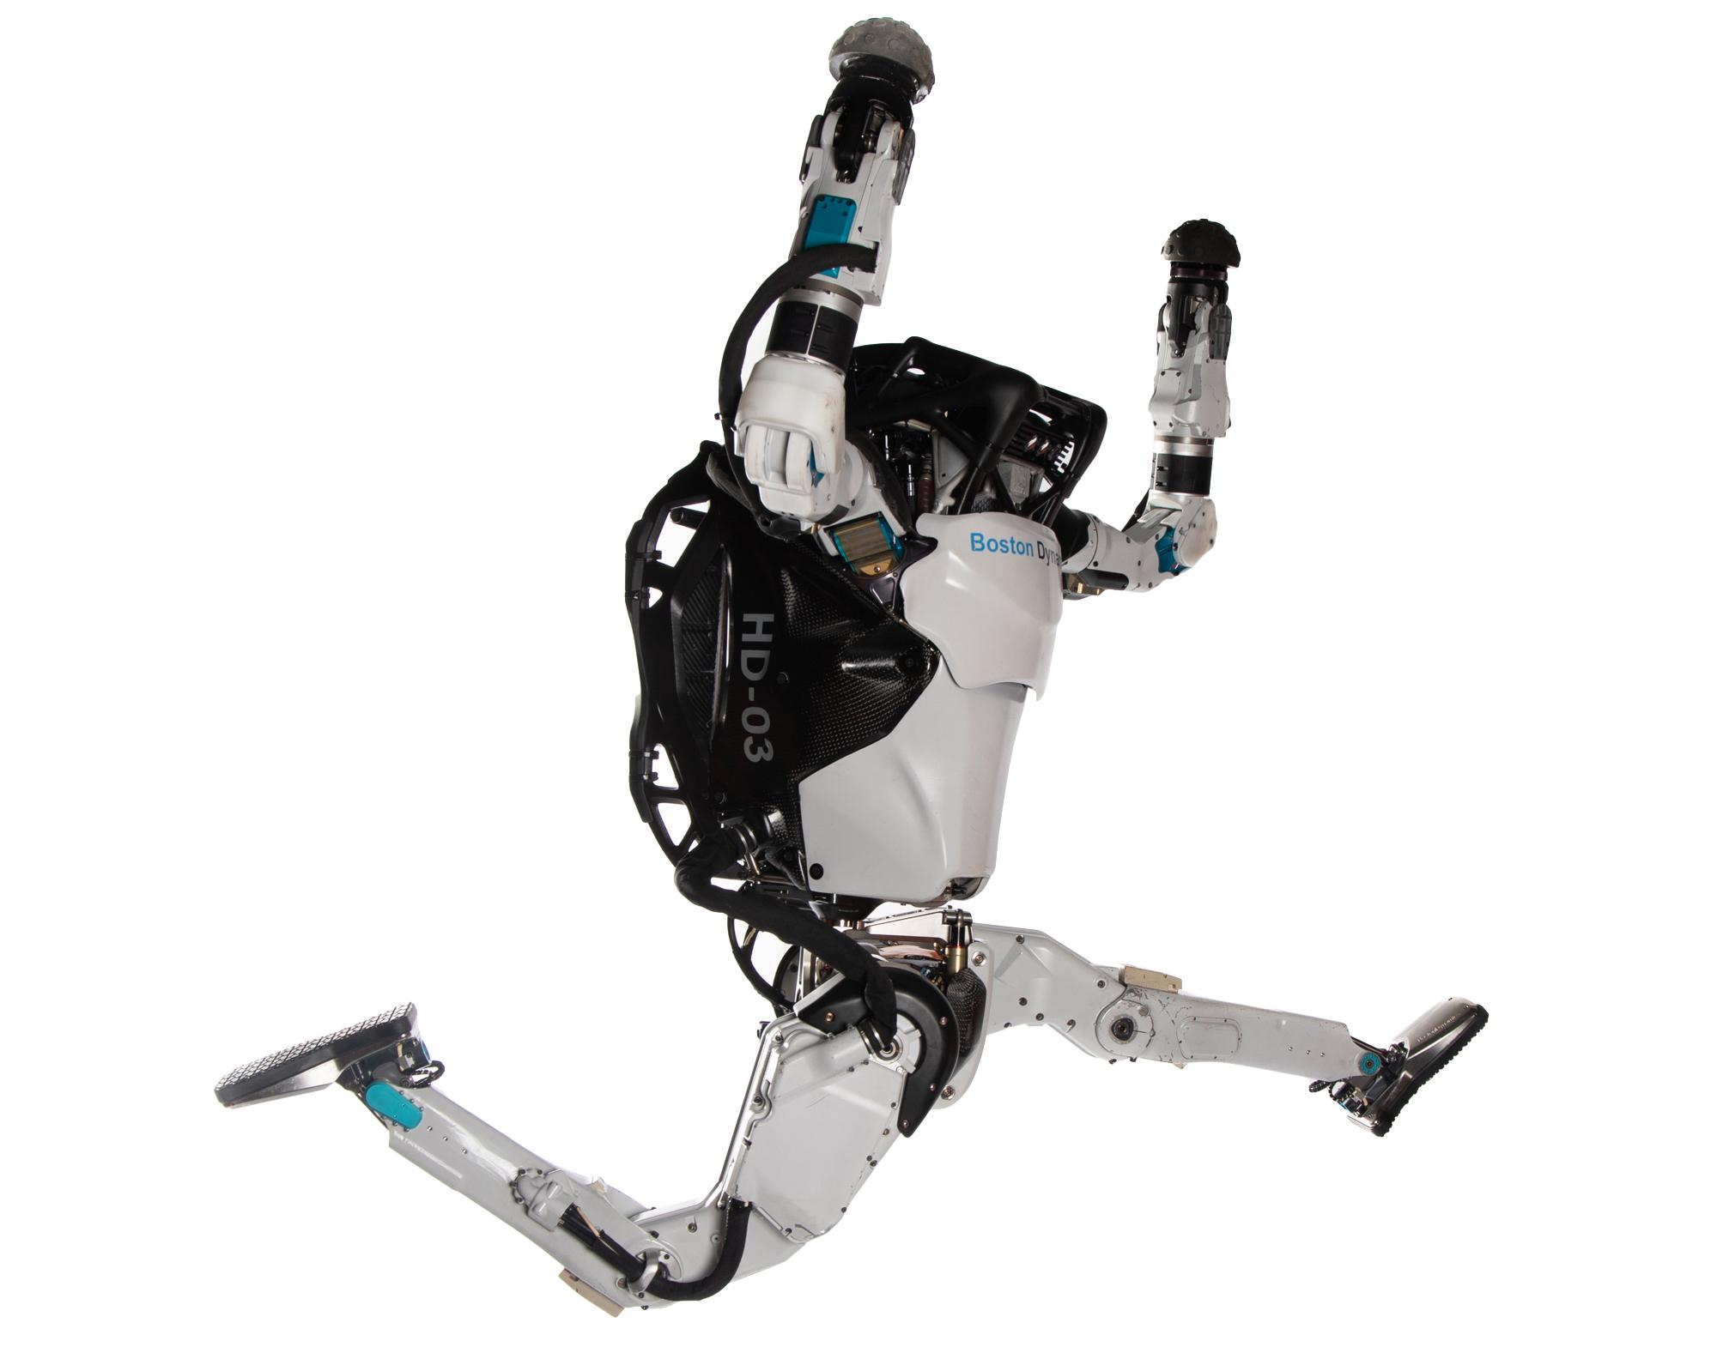

**Boston Dynamics’ Spot Robot:** Spot is an agile mobile robot that navigates terrain with unprecedented mobility, allowing you to automate routine inspection tasks and data capture safely, accurately, and frequently. Spot is the first commercial robot from a primarily research based company.

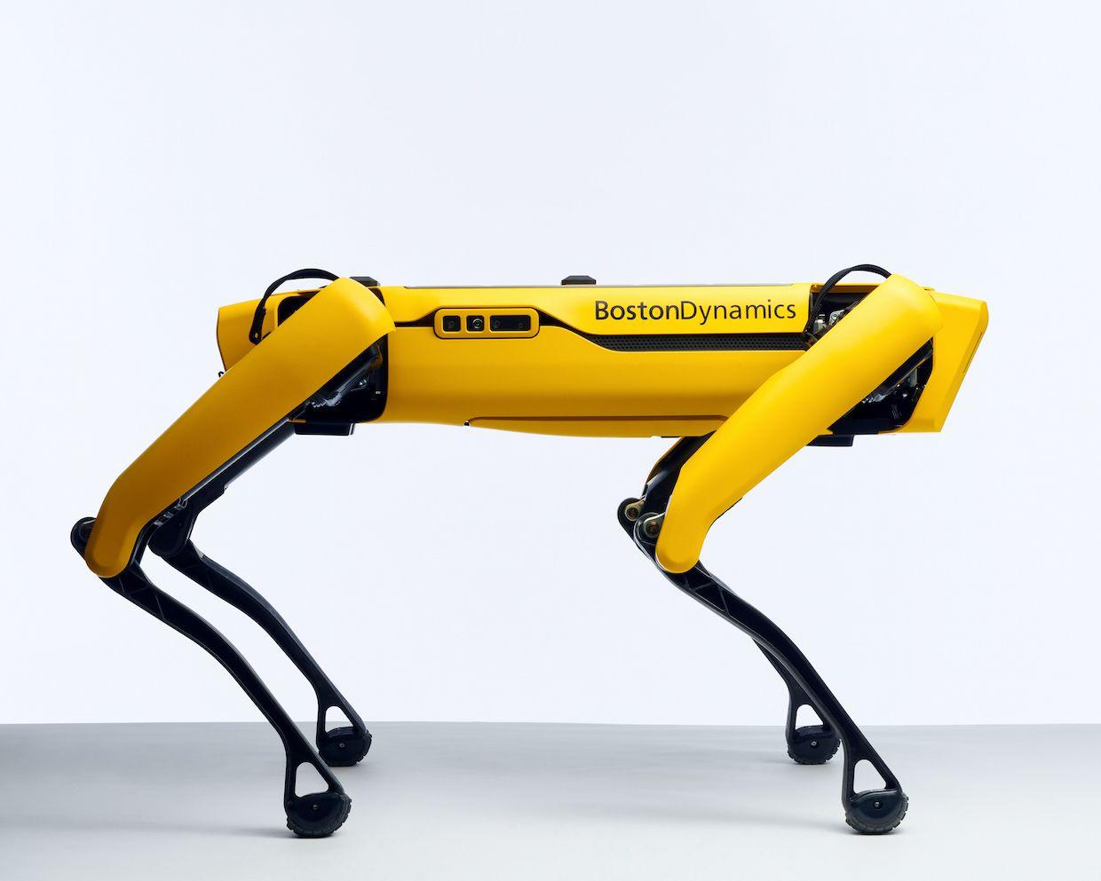

# Preliminary Material required and Associated costs

## Raspberry Pi Model 3B+ (Price: ~15000 Rs.)

This will work as the brain of the whole system.

## Servo Controllers ( x1 Price: ~ 1000 Rs. each)

The robot will use servo motors to control the movement of its joints and legs. Several Servo motors require a servo controller through which we are able to control around 16 motors with a few wires.

## Motors ( x16 Price: ~ 600 Rs. each)

The servo motors will be placed around the joints. 3 motors each in hip joints and 1 motor each for knee joints.

## Bearings Variable size ( x10 Price: ~ 300 Rs. each)

To support the free movement of the legs.

## IMU Sensor ( x1 Price: ~ 1000 Rs. each)

IMU sensors are used to give an idea about the environment to our robot.

## Total Estimated First Price: ~ Rs. 30,000.

# DESIGN TARGET:

Following picture should give a preview of what we will be aiming to design and develop in this study.

